Image Compression by B-Tree Triangular Coding
Riccardo Distasi, Michele Nappi, and Sergio Vitulano
IEEE Transactions on Communications, Vol. 45, No. 9, pp. 1095-1100, Sep. 1997
Abstract
This paper describes an algorithm for still image compression called B-tree triangular coding (BTTC). One advantage of BTTC over JPEG is its shorter execution time.
- Introduction
The coding scheme described in this paper is based on domain decomposition and linear interpolation. The interpolation performed by B-tree triangular coding requires only four floating-point multiplications and one division per pixel.
- The Coding Scheme
The image to be encoded can be regarded as a discrete surface, i.e., the surface A={(x, y, c) | c = F(x, y)}. Fig. 1 shows the surface corresponding to the test image lena.

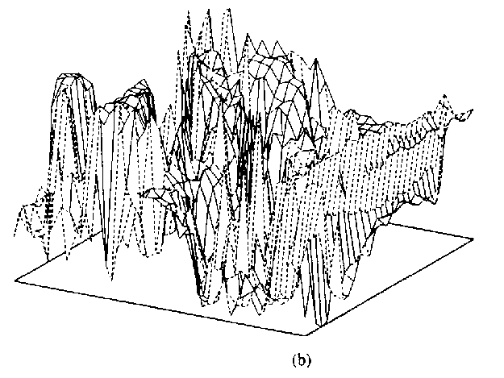
Our goal is to approximate A by a discrete surface B={(x, y, d)| d=G(x, y)}, defined by means of a finite set of polyhedrons. Fig. 2 shows a region of surface A being approximated by two URAT’s.
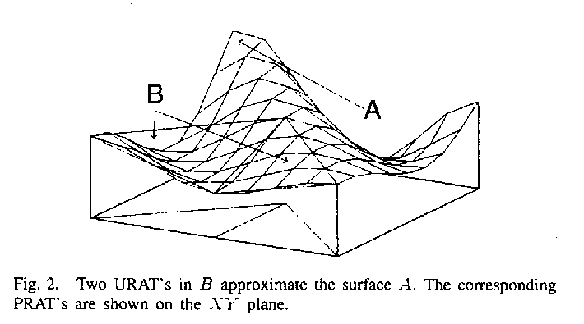

Example:
let T be a generic PRAT of vertices
P₁=(x₁, y₁), P₂=(x₂, y₂), P₃=(x₃, y₃)
and let
c₁=F(x₁, y₁), c₂=F(x₂, y₂), c₁=F(x₃, y₃)
so that
(x₁, y₁, c₁), (x₂, y₂, c₂), (x₃, y₃, c₃) ∈ A
The last three points define the URAT associated to T.
The restriction inside T of the approximating function S is given by the linear interpolation
G(x, y) = c₁ + α(c₂-c₁) + β(c₃-c₁)

- BTTC Compression
- Encoding
- input a image has side length m.
- the structure of the resulting B tree is stored in a binary string s obtained from a breadth-first visit of the tree.
- the heights of the URAT’s vertices are memorized after the binary string s.
- Decoding
- reconstructing the B-tree structure from the binary string s.
- the URAT ‘s are generated from the information just gathered.
- compute inside each PRAT in the list of leaves.
- reconstructing the surface B.
- Experimental Results

 |  |  | Table 1
Compression statistics for image lena
bpp | Total nodes | Leaves | Heights | bpp  (tree) | bpp (heights) | FLOPs  (x 10⁶)
0.35 | 35703 | 17853 | 9191 | 0.13 | 0.22 | 4.16
0.45 | 45273 | 22638 | 11688 | 0.16 | 0.29 | 4.24
0.68 | 67317 | 33660 | 17358 | 0.23 | 0.45 | 4.42
0.88 | 88105 | 44054 | 22757 | 0.30 | 0.58 | 4.57
1.00 | 103043 | 51523 | 26568 | 0.34 | 0.66 | 4.65
1.20 | 122829 | 61416 | 31641 | 0.40 | 0.80 | 4.82
1.43 | 149447 | 74725 | 38460 | 0.48 | 0.95 | 5.01
1.79 | 190793 | 95398 | 49010 | 0.60 | 1.19 | 5.45

Table 2
Distortion measures for lena
bpp | ε | PSNR  (BTTC) | RSNR  (BTTC) | MSE  (BTTC) | PSNR  (JPEG)
0.35 | 26.0 | 29.51 | 23.57 | 72.71 | 34.09
0.45 | 24.0 | 30.42 | 24.28 | 58.99 | 35.36
0.68 | 20.0 | 32.30 | 26.36 | 38.29 | 37.14
0.88 | 16.0 | 33.82 | 27.88 | 27.00 | 38.42
1.00 | 14.0 | 34.77 | 28.82 | 21.70 | 38.91
1.20 | 12.0 | 35.79 | 29.85 | 17.13 | 39.44
1.43 | 10.0 | 36.96 | 30.97 | 13.10 | 39.98
1.79 | 8.2 | 38.46 | 32.52 | 9.26 | 42.22

In contrast, BTTC’encoding has a smaller computing load that grows with the bit rate, while decoding requires only 1.8 million FLOP’s. JPEG requires about 5 million FLOP’s for encoding or decoding a 512 × 512 × 8 image.

- Conclusions
This paper has presented a new lossy algorithm for image compression. The asymptotic time complexity is O(nlogn) for coding and Θ(n) for decoding. It is simple to implement and highly parallel.

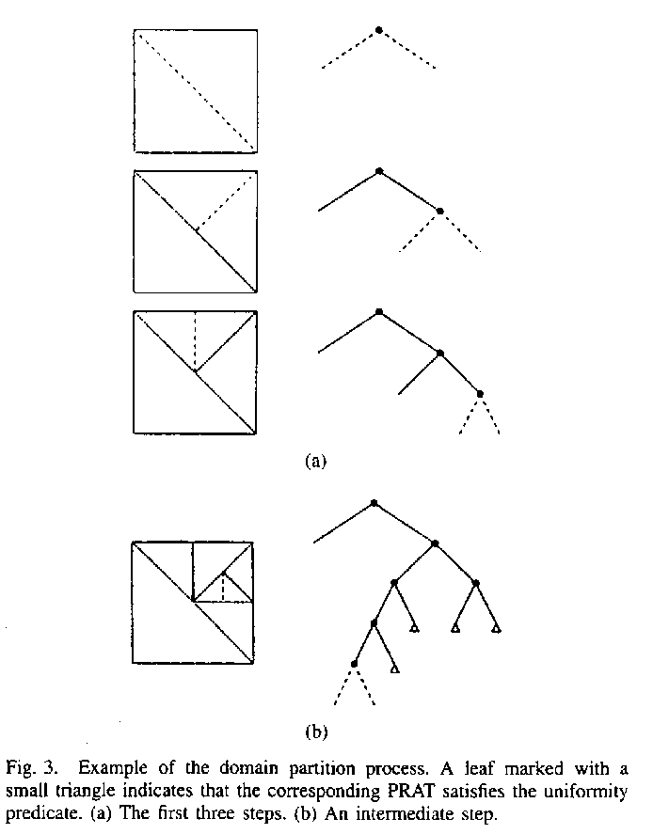

Created by : Chia-Hao Yang
Date : Mar 4, 1998

